The Monkerton Story: the planning and delivery of District Heating in a low density private housing scheme in Exeter.....without subsidy

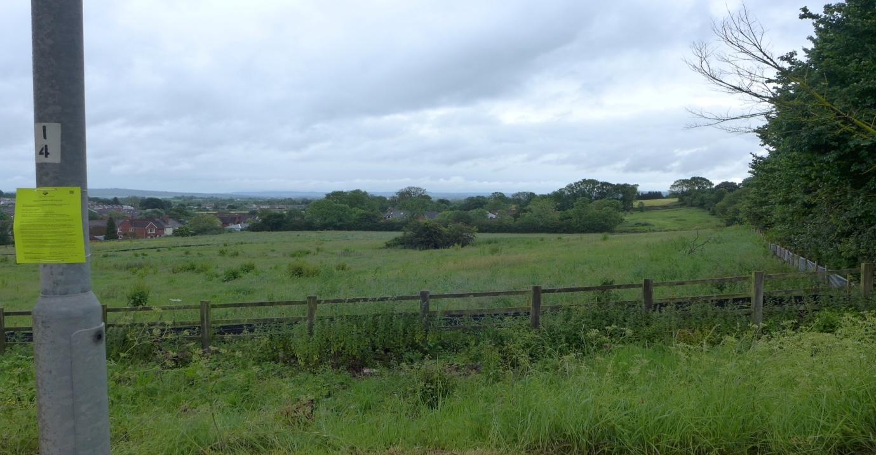
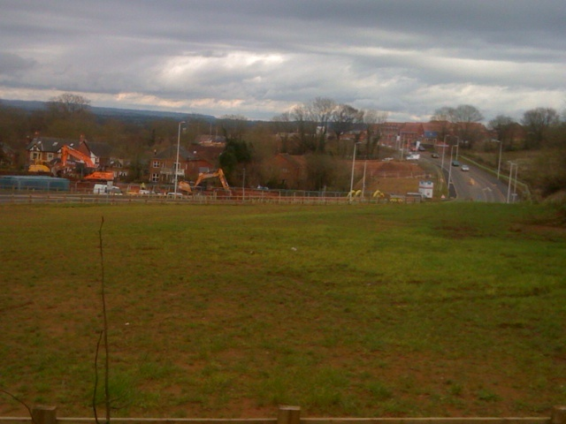
John Rigby April 2016
Chair, Exeter and East Devon Low Carbon Task Force

The Monkerton Story

1.Summary
1.1 This paper sets out the history behind the delivery of an extensive low density District Heating scheme in a new build private residential scheme at Monkerton on the east side of Exeter, without the provision of any grant aid. The delivery of DH at Monkerton faced some fundamental challenges from parts of the housebuilding sector and was achieved only as a result of careful policy preparation with a firm evidence base and sheer determination, including legal action to sustain the adopted planning policies. The paper underlines the benefit of long term public/private collaboration in delivering growth and low carbon infrastructure.

1.2 The exact circumstances are unlikely to be repeated elsewhere but many of the features of this negotiation are likely to be repeated. For the reader who is solely interested in DH delivery issues, then please turn to Sections 5 and 6. If however the development context is important, please read the full paper.

2. Background
2.1 Exeter is a compact historic City of 120,000 people with tight administrative boundaries. Some 35 % of the land area is designated as ‘Valley Park’ - a reflection of its setting on the Exe and its minor tributaries and of the intrinsic landscape quality which has resulted. It is bounded on the north and west sides by high ground of high landscape value. Exeter thus had relatively modest areas of land for future growth. The City tended to be perceived in the post war period as a pleasant County town, without a great deal of economic dynamism. It has a relatively small manufacturing base but acts as a service centre for the south west. There was a significant development boom in the 1980s which saw much of the remaining undeveloped land in the City occupied by new office and service sector activities. After that period of expansion, few options for further growth remained without building in the floodplain or on the prominent high ground which has considerable landscape value.
2.2 To grow further, Exeter has had to look to its neighbours – Teignbridge to the south west and, particularly, East Devon to the east. Moreover, as a District Council, strategic planning and transportation issues have sat with the County Council. Inter authority co-operation was thus essential if effective growth was to be delivered. Fortunately, despite significantly different socio economic characteristics and different political control between the authorities, a pragmatic approach to development has been taken over the last 20 years, resulting in the successful bidding for and re-location of the Met Office from Bracknell, followed by the translation of the proposal for a Science Park – met with initial scepticism - into a strategic facility which is now up and running. The impact of the Met Office re-location on the City’s growth prospects has been significant but the ability to respond to the subsequent growth pressures was somewhat circumscribed.
2.3 Whilst work on the delivery of a new community east of Exeter began in 1991, the spur to delivery was undoubtedly the launch of the competitive bidding by the government for Growth Point designation in late 2005. Some 50 Growth Points were designated in two rounds and the Exeter and East Devon area was one of these. The bid promised an increase of 26,000 jobs and 20,000 households in the Growth Point area – to be delivered by 2026, by the three bidding authorities – East Devon District Council, Exeter City Council and Devon County Council. The bulk of the growth was to be allocated to the new community of Cranbrook, two miles east of the Exeter boundary but an additional 12,000dwellings needed to be accommodated within Exeter between 2006 and 2026. The proposals for the City were included in the Core Strategy which was in preparation from 2005 and approved in 2012. Three major development sites were allocated: Newcourt(3500 dwellings); Monkerton (2500 dwellings); and south west Exeter (2500 dwellings of which 500 were in Exeter and the remainder in Teignbridge). The latter two sites also had employment land allocated, in addition.
2.4 Although this paper focuses on the Monkerton allocation, the ground breaking work at Cranbrook should be briefly outlined, as that set the context for both the framing of policy and the approach to delivery at Monkerton.
2.5 Cranbrook was designated originally as a new community with 2900 dwellings approved in the first phase, growing to 6000 dwellings by 2026. As time has passed, this has moved to an expectation that this would ultimately rise to 7500 dwellings. At the conceptual stage the local authority wanted to ensure that this was a sustainable community. A laudable aim but one which has been commonly adopted around the country, but is often no more than a piece of marketing gloss. The Growth Point Project Team commissioned Element Energy to advise on the CO2 implications of the developments then being proposed across the Growth Point over the period to 2020 and to recommend the best approach for minimising the CO2 impacts. Their 2008 report concluded that:
‘Large sites across the Growth Point requiring intermediate carbon reductions (level 4 and above) will be most cost effectively served by site wide district heating; at higher code levels, this would be augmented with biomass CHP.’
Source: ‘East of Exeter New Growth Point: Energy Strategy’. Element Energy. 2008
(Available on East Devon District Council’s website)
2.6 Element Energy’s key recommendations included: Early adoption of the Code for Sustainable Homes; site wide energy systems; adoption of a low carbon strategy; the adoption of DH networks on commercial sites; and supporting the deployment of an Energy from Waste plant. These recommendations have very much defined the focus of the collaborative work over the last seven years.
2.7 At Cranbrook, EDDC, supported by the HCA, facilitated a negotiation between the developers and E.ON for the construction of a Combined Heat and Power Plant, with a biomass obligation as part of the planning consent for the first phase of Cranbrook. The CHP plant was to be linked to an 80 km district heating pipe network, which, with improved home insulation, would deliver zero carbon housing. Whilst the housebuilder consortium expressed considerable scepticism about constructing new dwellings without individual gas supplies and conventional central heating boilers, the combination of local authority policy and pressure from the HCA, linked with grant provision, resulted in agreement to a CHP plant and DH network at Cranbrook. The first dwellings were occupied in mid 2012 and there are now more than 1200 dwellings occupied.
2.8 The key point about Cranbrook is that the precedent had been established for the delivery of DH in a large low density housing scheme.

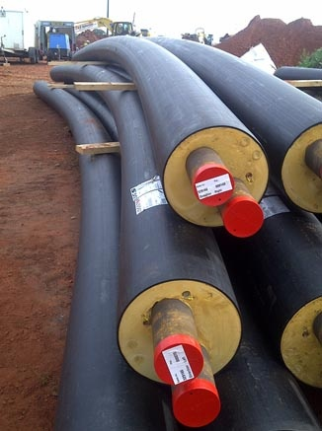

Super insulated pipe
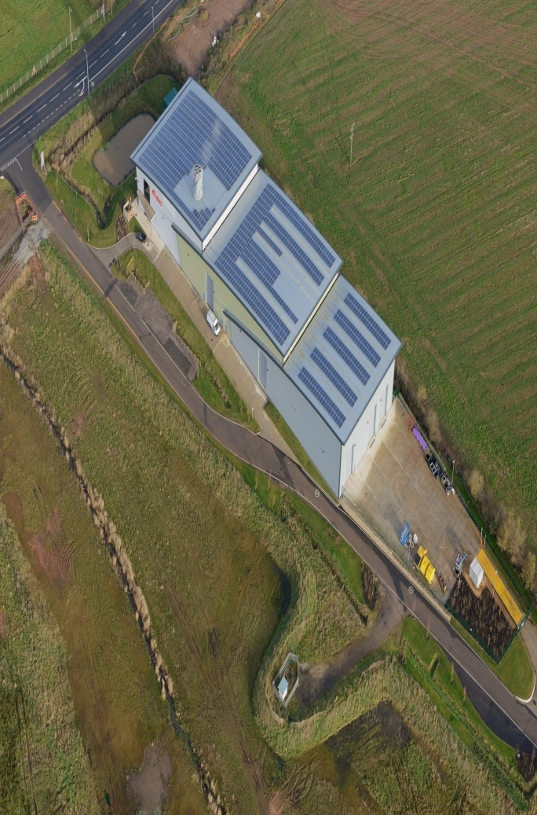

E.ON Energy Centre at Cranbrook

3. Planning context
3.1 The initial driver for Exeter City Council’s consideration of low carbon aspirations in their planning policies was the publication of the Code for Sustainable Homes in 2006, which, although voluntary initially, became mandatory in 2008. The enactment of the Climate Change Act, 2008, with almost unanimous support in Parliament, also set an over-arching context, that CO2 reduction was to be a fundamental objective of economic, environmental and planning policies. The Council began preparation of its Core Strategy in 2005with a Preferred Options consultation in 2006. Provision for Renewable Energy featured in this and was widely supported but at that stage, the draft requirement was simply a need to achieve a 10 % reduction in CO2 levels. With the Growth Point having commissioned the Element Energy advice which was completed in 2008, the City Council was presented with an evidence base that justified a more comprehensive approach to energy infrastructure, building design and CO2 reductions. In 2010, the Council also received a comprehensive briefing on carbon emissions and proposed reductions, along with a strategy for addressing these issues.
3.2 Reflecting this rapidly changed context, the draft Core Strategy published in 2010 included a quite substantial shift in approach with an extended section on ‘Transition to a Low Carbon Economy’ and a set of specific policies to help achieve this transition. In terms of energy networks, the key policy was:
CP13: Decentralised Energy Networks will be developed and brought forward. New development (either new build or conversion) with a floorspace of at least 1,000 square metres, or comprising ten or more dwellings, will be required to connect to any existing, or proposed, Decentralised Energy Network in the locality to bring forward low and zero carbon energy supply and distribution.

3.3 The City Council commissioned additional technical work from the Centre for Energy and the Environment at Exeter University and made further modifications to the policy before consideration at the Public Inquiry into the Core Strategy:
CP13: Decentralised Energy Networks will be developed and brought forward. New development (either new build or conversion) with a floorspace of at least 1,000 square metres, or comprising ten or more dwellings, will be required to connect to any existing, or proposed, Decentralised Energy Network in the locality to bring forward low and zero carbon energy supply and distribution. Otherwise, it will be necessary to demonstrate that it would not be viable or feasible to do so. Where this is the case, alternative solutions that would result in the same or better carbon reduction must be explored and implemented, unless it can be demonstrated that they would not be viable or feasible.
In endorsing the policy, the Inspector particularly noted that it was supported by the East of Exeter New Growth Point Energy Strategy, prepared by Element Energy, demonstrating the importance of sound quantitative research to back innovative planning policies.
3.4 In parallel with the preparation of the Core Strategy, Exeter needed to advance its delivery of strategic sites if it was to fulfil its commitment to the Growth agenda. The City Council decided in 2009 that the preparation of a Master Plan for the Monkerton area, comprising a 170 ha study area (part of which was already developed with a business park, including the Met Office HQ), was critical for the effective planning of this major development. Crucially, this plan was commissioned by the Council, Devon County Council, the landowners and the Highways Agency. Thus, ownership of the finished plan by all major parties was a key feature. The Plan had a detailed section on the ‘Energy Framework’, the principal conclusion of which was:
‘It is therefore considered that a community system, established during the first phase of the development and then expanded from multiple starting points, would offer the most advantageous method of meeting the carbon reduction targets for the development as a whole. The opportunities for possible community energy infrastructure for each of the phases identified in Section 6 are summarised below.’
3.5 Following the adoption of the Master Plan, three landowners proceeded with outline planning applications in order to establish the general principles of their respective part of the development area. Resolutions to grant were made on key parts of the site from December 2012 onwards. Due to extended negotiations on the accompanying 106 Agreements, consents were not issued until November2013. The imperative for completion was the anticipated changes to ECC’s Affordable Housing Policy and the introduction of the Community Infrastructure Levy.
4. Delivering DH at Monkerton : the outline proposal
4.1 Following an approach by E.ON in 2011, the City Council established a partnership which encompassed the four local authorities, E.ON, the Chamber of Commerce, the Met Office, the Energy Saving Trust, the Royal Devon and Exeter NHS Trust and the University. The Low Carbon Task Force (LCTF) was a vehicle for designing and delivering carbon savings across a range of planning, energy and transport projects in the Growth Area. Delivering District Heating in major development areas was seen as one of the core tasks of LCTF and early steps were taken to establish an implementable proposal for Monkerton. E.ON had already demonstrated that they were a utility that would deliver DH in partnership with others by virtue of their work on Cranbrook.
4.2 Their proposal was to provide a Combined Heat and Power plant and a pipe network to serve the whole Monkerton development. The scheme would be funded by E.ON corporate funding, financed by a long term revenue stream from heat sales, with the funding gap filled by a fixed connection fee for each property connected to the DH system. The revenue stream would be guaranteed by the developers offering a long term concession to E.ON, with a commitment not to run low pressure gas to the site for individual consumers. That would be delivered by the signing of Heads of Terms, followed by a binding legal agreement. Initially, the concept was to use the CHP plant already operating at the Met Office in the southern part of the site. This would have provided sufficient heat for one of the developers who had engaged very positively in the discussions on delivering DH but this was for a scheme serving just under1000 dwellings.
4.3 As the proposal developed, it was clear that a single site wide system was needed, serving nearly 3,000 dwellings. The Met Office CHP was not big enough for this,nor, because of building constraints, could it be expanded to cope with the higher load. After discussions with the landowners (and failure to secure a site on any of the land already owned by the housebuilders), Devon County Council agreed to lease E.ON a site on land that they owned. As this was immediately adjacent to the M5 and in a depression next to the motorway embankment, this was an ideal location for the Energy Centre. Provision was made for the network to be expanded under the M5 to serve additional residential sites being brought forward in east Devon and to serve the Science Park which had planning consent and was proceeding.
4.4 At this stage (Spring 2012), the proposal offered by E.ON was for an 80 year concession, with a connection fee of £4900 for 2900 dwellings. The developers’ response was mixed, with an acceptance that DH in principle was acceptable, but they had concerns about the level of the connection fee in a market that was only just beginning to recover from the 2008 crash and strong reservations about why only E.ON were in the frame, as opposed to a more competitive process delivering several interested utilities. The developers argued that grant should be available, as it had been at Cranbrook, and that other utilities should be brought in. The response was that all low carbon infrastructure grants for this sort of project had now gone but that the Growth Point would bid for loan funding to bring the connection fee down. This bid was successful but in the end the facility was not used, as E.ON worked with the parties to lower the delivery cost and also accepted reduced margins. The result of this revised financing package was that the proposed connection fee was reduced to £3950 for 2863 dwellings in a revised offer in September 2013 – a key psychological shift. The concession moved to a 77 year length to be coterminous with the Cranbrook deal.
4.5 The difficulty of bringing in another utility was a combination of lack of time – developers wanted to conclude any deal in less than a year – and lack of clear evidence of other parties willing to make competitive offers. Our recommended solution was to obtain independent evidence that the deal offered was one that benchmarked competitively with others elsewhere in the country.
4.6 The negotiations proved exceptionally slow as E.ON felt unable to do detailed design work until (non binding) Heads of Terms were signed and the housebuilders continued to keep their options open. The situation was brought to a head when the City Council set a deadline of 1 December 2013 for the introduction of its new CIL planning contributions. Very shortly before this deadline, it secured the agreement of three landowners to sign draft section 106 Agreements to deliver DH, along with signature of the E.ON Heads of Terms, to avoid re-starting the negotiations on planning contributions under the new system. This marked a key milestone which established momentum in the DH negotiations.
4.7 From late 2013, the ‘simple’ challenge was to deliver a legal framework acceptable to all parties and to convince the developers that a workable scheme could be delivered at a competitive price. Up to this point, negotiations had taken ten meetings. From end 2013 to November 2015 when all the legal processes had been completed, it took a further eight meetings and a High Court injunction to resolve the outstanding issues. The following section outlines the challenges encountered.

5. Delivering DH at Monkerton: The Challenges
Housebuilder attitudes
5.1 The housebuilders involved in Cranbrook were not overly enthusiastic about the adoption of DH as the prescribed heating solution for the new community. It was unfamiliar and untested with British consumers in low density development on any scale. What greatly helped the Monkerton negotiation, with the passage of time, was that several hundred houses were occupied in Cranbrook between mid 2012 and mid 2014. Whilst there were teething problems with both installation and initial operation, E.ON were assiduous in resolving these quickly and with the minimum of fuss. The legal documentation for the Cranbrook development specified notification and response times and E.ON made sure that these were adhered to. Along the way, operational performance was addressed by upgrading HIU components and E.ON changed from using sub-contractors who proved unreliable to having directly employed installation and maintenance staff. E.ON also held weekly heat network installation programme meetings with each hosuebuilder to improve the reliability and timeliness of installation. Residents’ groups and E.ON worked together closely to resolve teething issues, with customer surgeries held to deal with any engineering or billing problems, thereby ‘nipping problems in the bud’. The net effect was clear: Persimmon Homes who are a core part of both the Cranbrook consortium and of the Monkerton development moved by early 2014 to being key advocates of District Heating.
5.2 Whilst the principle of DH became much less contentious through the negotiation process for Monkerton, the disparate timetables of the developers remained a major obstacle. The build programme of Linden Homes was such that their desire to be on site in late 2014 became a major issue during the latter stages of the negotiation. Others were more relaxed about the timetable. Although a Development Agreement between the parties would have overcome this, this was not something the parties would agree to.
5.3 One further landowner issue relating to the principle of DH was the inability to tie in successors in title to the Heads of Terms agreed in November 2013. Thus whilst the standard section 106 set out the basis on which DH would be required (see Annex 2), the Heads of Terms provided important additional detail (key extracts in Annex 3). When one party to the HoT sold on to a housebuilder in 2014, there was no carry forward to the new owner of the key principles of the deal. A second landowner came close to a land sale and the new potential owner was insistent that they were not going to participate in a site wide DH solution but would pursue their own which was allegedly better value for money – though no submission was ever made to evidence this cheaper DH system.
The legal structure
5.4 The primary legal document setting out the deal was the Master Agreement. This was to be supported by three other agreements. This was not approached from scratch but instead the Cranbrook documentation was taken as the template. One major step taken by the developers was to agree that they would appoint a single lawyer (Clarke Willmott) who dealt with Cranbrook to act for all of them and that the Persimmon MD would lead on the instruction of the lawyers and negotiations with E.ON, recognising that the experience of the Cranbrook deal would be invaluable to the process. Over the course of the two years of detailed negotiations, this extended to 10 agreements (see summary in Annex 4). Part of the reason for this expanded documentation was a clear need to respond to potentially insuperable problems that arose latterly in the negotiations that required bespoke solutions.
5.5 Two problems should be highlighted which ultimately were resolved by a single solution. First, there was a need to provide effectively for customers seeking redress for poor performance. For electricity and gas supply, the market is regulated so the remedies through the aegis of the regulator are clear. But, the heat market is at present unregulated. Whilst the main MA provided for performance oversight and control, with remedies, ultimately including termination of the concession, the realism of that remedy being exercised by individual householders was slight and since the developers weren’t prepared to establish a management company, it required a different solution. The second was the use of easements to install the significant length of pipework required. In Cranbrook, easements had been used which had been straightforward but the more complex land ownership pattern and E.ON’s desire for flexibility in future ownership structures forced the move towards creating a set of leasehold interests. With leasehold interests created, a vehicle was needed to hold these for the lifetime of the scheme and beyond if the concession was renewed.
The Monkerton Heat Company
5.6 The solution to these issues was the creation of the Monkerton Heat Company (MHC), a company which would be owned by all of the developers and Exeter City Council to begin with. As each developer completes their site, they drop out of the MHC, leaving the City Council as the sole owner at the completion of the whole scheme. ECC would have some liabilities in the form of an obligation to pursue E.ON for poor performance, potentially exposing the Council to significant legal costs if they took action which ultimately failed. If the Council were however successful, their costs would be covered. The assets comprise the various leaseholds for the pipework (probably in truth not worth very much) but a much greater asset in monetary terms if the E.ON concession were terminated and had to be re-let. ECC had to carefully weigh up this liability and ultimately, Members confirmed in July 2015 that they were prepared to take on this role. In due course, this role could pass to the Energy Service Company which ECC plan to establish (with partners) to deliver low carbon solutions in greater Exeter.

The change in zero carbon aspirations of government
5.7 The core driver for DH was that whilst Code 3 compliance could be economically achieved by individual fabric measures, Code 4 which the government stated in 2008 would come into play in 2013 would be the principal factor in DH policy compliance because it was the most cost effective means of delivering the higher standard of carbon emissions control. This was in line with the research and advice provided by Element Energy. Unfortunately, the planned level of Code 4 carbon reduction was reduced by DCLG in 2013 from a 44 % CO2 reduction to 29% and the effective date for the new Part L was moved back from 2013 to 2014. This left the public sector team concerned that some of the developer side may well decide to challenge the DH obligation on the basis that they may be able to deliver carbon reductions more cheaply. Fortunately, the line held and it may well be that the repeated re-affirmation of the government’s intention to hit zero carbon in 2016 was a key piece of the background context. When the government announced in July 2015 that they were abandoning zero carbon, the public sector did fear that this could de-rail negotiations in the closing stages. It was perhaps a co-incidence but very shortly after this, one developer did resolve to challenge the policy. In a second scheme under negotiation in SW Exeter, the lead developer voiced a direct challenge to the policy, based on the notion that DH was an expensive means of delivering the legally required (part L) carbon reduction, as opposed to that set out in Local Plans.
5.8 Perhaps the crucial back stop for the negotiations was however the fact that ECC had incorporated the Code for Sustainable Homes carbon reduction targets directly into its Core Strategy policies. CP15 specifically required a 44% reduction in CO2 for any dwellings which had not been commenced before January 2013. Thus, whilst house by house solutions could have been applied to meet that standard, it is probable that the housebuilder judgement was that this was less economic than a site wide DH scheme.
Legal tests – viability, feasibility and availability
5.9 Despite clear signs that developers were for the most part comfortable with the principle of DH, there continued to be expressions of concern about viability, feasibility and availability. These were the criteria set out in the adopted Policy CP13 and mirrored in the section 106 for judging whether the DH connection obligation should be fulfilled. ‘Feasibility’ was effectively answered by the implementation and operation of the system at Cranbrook – with a scheme of similar size in a development of a similar nature, it could hardly be claimed in any legal test that DH was not feasible. Regarding ‘viability’, the housebuilders commissioned Inventa and Partners in April 2015 to advise them. That advice was confidential to the housebuilders. Whilst the connection fee remained at £3950 per dwelling, negotiations between the parties resulted in a compromise over inflation provisions and the inclusion of a rebate mechanism which would credit the original parties to the agreement, as more sites came forward. The latter was a useful innovation in so far as the deal encouraged the core partners to sign up.
5.10 ‘Availability’ was the most difficult area in the closing stages of the negotiation. The need to modify the original scope of the legal documentation and resolve a range of differences between the parties meant that a final deal was running significantly behind schedule. A scheme was ‘available’ in the sense that it had been designed and costed and broad agreement existed on the commercial terms. But, without a final set of legal documentation, the scheme could not start on site. Linden Homes became increasingly anxious that this would substantially delay their build programme
Judicial Challenge
5.11 Linden Homes had started on site in mid June 2015, doing preparatory groundworks. By late July, it was apparent that they were laying a gas supply to each of the properties in the first phase of development. Whilst the City Council and E.ON had suspected, for approaching a year, that this had been their intention, no hard evidence (adequate for enforcement purposes) was available that the housebuilder was planning to side-step the DH requirement. The City Council took immediate steps to challenge this and started court proceedings to secure an injunction against Linden to ‘not carry out or commission any works of construction on the development land that would prevent the installation of the district heating system network to enable connection to the District Heating Facility referred to at clause I of Schedule 2 of the Agreement’. (The Agreement refers to the Section 106 Agreement, a copy of which forms Annex 2).
5.12 Papers submitted to the County Court were considered on 17 August and the Court granted an Interim Injunction to the City Council, pending a full hearing on 12/13 October. A meeting of all the parties was held on 14 August and the Homes and Communities Agency Regional Director asked to chair it. It was not simply the City Council that expressed its disappointment at Linden challenging the DH policy but the other housebuilders were also deeply unhappy. The core defence of Linden was ‘programme’. The response was twofold – first, that the legal documentation was by then all but complete and would be circulating within days for signature and second, that E.ON could mobilise within days to meet Linden’s programme, provided the parties had all signed the documentation. Despite a full High Court hearing scheduled for mid October, work on site proceeded apace, with site roads (now with low pressure gas mains installed) being completed to a finished surface level – extremely unusual on a housing site at such an early stage. The final documentation was signed by all the other parties during September but discussions between the E.ON and Linden continued over timetable and abortive costs provisions before a verbal deal was agreed on the eve of the full Injunction hearing. The final signatures on the documentation were added at the beginning of November and it was executed on 9 November, with a start on site by E.ON the day after.
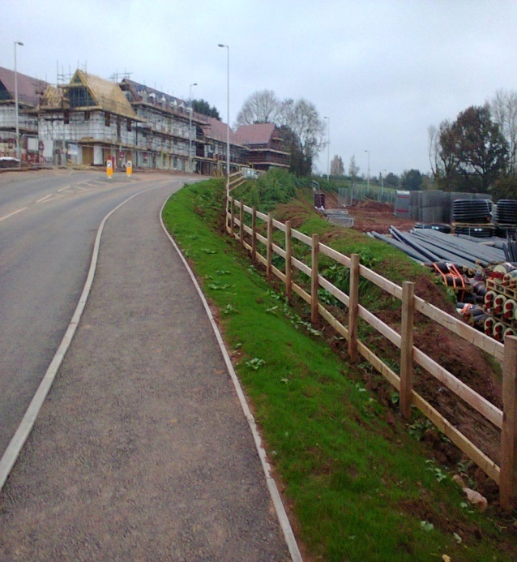
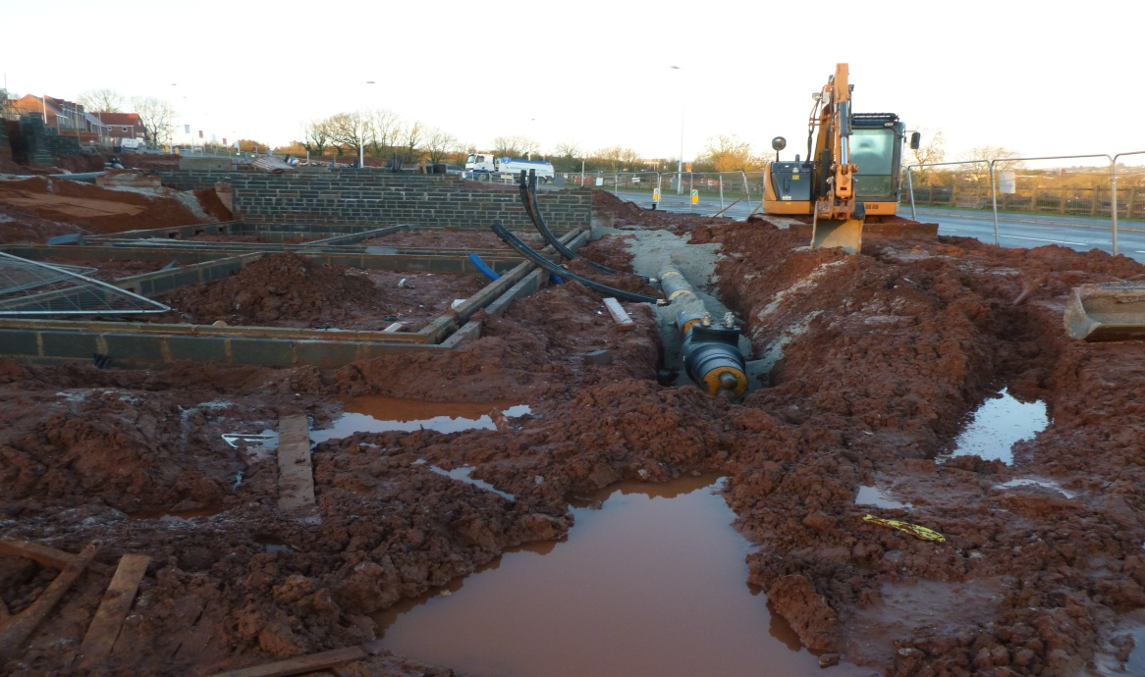
Heat pipes on site at Monkerton, Nov 2015

Monkerton site: February 2016

6. Lessons
6.1 The City Council and LCTF achieved what they had set out to do some five years previously when the Monkerton Master Plan was drafted in the shadow of the emerging Core Strategy. Whilst to an external audience, this might seem like a straightforward process – ‘set the policy,then implement it’ – in truth, the delivery of DH came close to failure on a number of occasions. Several of the lead ‘players’ commented after the deal was concluded that they had had severe doubts, during the negotiation, that the scheme would ever be achieved. There are a number of key factors that make success more likely:
1) Planning policy must be clear in its requirements and derived from a sound evidence base which can be demonstrated under challenge at Inquiry or in the Courts
2) Adequate triggers are needed for the local planning authority to take action if a particular developer decides not to play ball.
3) Thus, the LPA needs to be bound into all legal documents so that they are a party to developer undertakings.
4) Planning consents should include conditions and/or section 106 provisions which provide for triggers to monitor implementation and take enforcement action if not adhered to.
5) The LPA needs to be prepared to be tough on enforcement, going to court if necessary. Officers and Members may be reluctant to do this but policies become toothless if not enforced.
6) Comprehensive documentary evidence of negotiations and progress reports are essential for providing an evidence base to back a case which ends up in Court.
7) A competent ‘can do’ utility partner is essential that can inform a reluctant developer that they are able to address technical, engineering and supply issues at speed and with reliability.
6.2 A more detailed note on the lessons learnt, specific to this negotiation is appended at Annex 5 and the latest version of the Section 106, taking on board key lessons forms Annex 6. A timeline is included as Annex 7.
6.3 This note summarises the work of a range of public and private sector partners. If you would like clarification of any aspect, please contact:
John Rigby, Chair Exeter Low Carbon Task Force: jpecrigby@btopenworld.com
Howard Smith, Principal Project Manager at Exeter City Council: howard.smith@exeter.gov.uk
Andy Wood, Director, Growth Point: andy.wood@eastdevon.gov.uk
Tony Norton, Director, Centre for Energy and the Environment, University of Exeter: A.D.S.Norton@exeter.ac.uk
Mark Simpson, Senior Business Development Manager, E.ON: mark.simpson@E.ONenergy.com
I am grateful to the above colleagues and many others who have worked on the planning and delivery of this system and who have helped with the drafting of this paper.
John Rigby
15/04/16
FINAL(1)

Annex 1. Key Planning Policies

Issues and Options 2005
6.2 There is a general consensus that the use of oil, coal and natural gas to supply power and heating is the main cause of global warming. The Core Strategy could require major new developments to include renewable energy facilities such as solar panels or wind turbines to help meet their energy needs. Although the amount produced may be small, the requirement could promote the use of renewable energy and might help to reduce installation costs because of the increased demand for the equipment. It could be specified that at least 10% of a buildings energy needs should be met by renewable energy sources. Otherwise contributions could be sought towards the development of renewable energy sources elsewhere or insulation of new buildings could be required to be of an especially high standard. 13. Should major new developments be required to include facilities to generate renewable energy?

Preferred Options 2006
Renewable Energy
11.16 The Government, in the Energy Review, published in July 2006, proposes that 20% of the UK electricity requirement be met from renewable sources by 2021. Renewable sources of energy include sun, wind and water power, ground source heat pumps, biomass energy from organic matter, and combustion of waste materials. These can offer diversity and security of supply and can reduce harmful emissions to the environment. 11.17 Planning Policy Statement 22: Renewable Energy, published by the ODPM in 2004, emphasises the importance of developing positively expressed policies on integrating renewable energy in new development. This is also advocated by the Energy Review. This approach is carried forward by draft Regional Spatial Strategy policy RE5 which asks, as a minimum, for 10% on-site renewable energy provision on large-scale development. Issues and Options Consultation Response 11.18 There was strong public support for renewable energy to be included in major new developments. Views were, however, expressed that renewable energy requirements should be specific to the site and nature of the development, that policy can request but not require provision, and that renewable energy provision is not economically viable at this time. As the Government and the Regional Spatial Strategy strongly support the 10% policy, and this is supported by the public, it is appropriate to progress with this policy. Renewable Energy Requirements 11.19 Major new developments should include renewable energy facilities, such as solar panels or wind turbines, to help meet their energy needs. Although the amount produced may be small, the requirement will promote the use of renewable energy and might help to reduce installation costs because of the increased demand for the equipment. 11.20 Within Exeter the most promising sources of renewable energy generation within developments are likely to be photovoltaic cells (which respond to daylight), passive and active solar heating (which respond to sunlight respectively through location and through solar panels), small scale wind turbines, ground-source heat pumps and biomass heating. Different sources of generation produce different types of energy, for example photovoltaic cells produce electricity and ground-source heat pumps and biomass produce heat. External funding is increasingly available to support renewable energy installations, when initial costs are high. 11.21 A policy requiring that a proportion of overall energy needs in new developments must be met by provision of renewable energy sources on the site should be applied to developments of all kinds, including mixed used proposals above a reasonable size. A major aim of the policy is to encourage energy saving and reduce overall reliance on energy supplies (see also 11.23 – 11.26 below). If energy saving measures are introduced, the energy efficiency of a development will be improved and the need for renewable energy production equipment will be reduced, thereby resulting in lower overall costs. 11.22 Detailed guidance on the provision of renewable energy will be set out in an advice note.
CP16: ALL DEVELOPMENT (EITHER NEW BUILD OR CONVERSION) WITH A FLOORSPACE OF 1,000 SQ. METRES OR TEN OR MORE DWELLINGS WILL BE REQUIRED TO INCORPORATE RENEWABLE ENERGY PRODUCTION EQUIPMENT TO CUT CO2 EMISSIONS BY AT LEAST 10%.

Adopted Core Strategy
CP13: Decentralised Energy Networks will be developed and brought forward. New development (either new build or conversion) with a floorspace of at least 1,000 square metres, or comprising ten or more dwellings, will be required to connect to any existing, or proposed, Decentralised Energy Network in the locality to bring forward low and zero carbon energy supply and distribution. Otherwise, it will be necessary to demonstrate that it would not be viable or feasible to do so. Where this is the case, alternative solutions that would result in the same or better carbon reduction must be explored and implemented, unless it can be demonstrated that they would not be viable or feasible.
CP14: New development (either new build or conversion) with a floorspace of at least 1,000 sq. metres, or comprising ten or more dwellings, will be required to use decentralised and renewable or low carbon energy sources, to cut predicted CO2 emissions by the equivalent of at least 10% over and above those required to meet the building regulations current at the time of building regulations approval, unless it can be demonstrated that it would not be viable or feasible to do so.
10.29 The Government has introduced the Code for Sustainable Homes to cover residential development. This code applies different rating levels for homes based on a range of criteria such as CO2 emissions, water efficiency, materials and site waste management. The sustainability rating represents overall performance across the Code’s nine design categories. Apart from some minimum standards the Code is flexible to allow developers to choose how they wish to obtain points in order to achieve a particular rating. The Government intends to introduce a similar Code for non-residential buildings, and has indicated that non-residential buildings should be zero carbon from 2019, with public sector buildings achieving this status one year earlier, in 2018.

The Code for Sustainable Homes
Code level Energy standard (reduction from 2006 Part L) Year
3 25% 2010
4 44% 2013
5 Zero carbon 2016

CP15: Proposals for development are expected to demonstrate how sustainable design and construction methods will be incorporated. All development must be resilient to climate change (particularly summer overheating) and optimise energy and water efficiency through appropriate design, insulation, layout, orientation, landscaping and materials, and by using technologies that reduce carbon emissions. Residential development will be required to achieve the above (Para 10.29) Code for Sustainable Homes Level (overall performance across the code categories and complying with minimum standards). All non-domestic development will be required to achieve BREEAM ‘Very Good’ standards increasing to ‘Excellent’ standards from 2013. Non-domestic buildings are expected to be zero carbon from 2019. Due to their scale the Monkerton/Hill Barton, Newcourt and Alphington urban extensions should achieve levels of sustainability in advance of those set out nationally.

Annex 2 Standard Section 106 Agreement

Schedule 2

District Heating Facility
- The Developer shall connect each Dwelling to a District Heating Facility PROVIDED THAT in the event that the Developer can demonstrate to the reasonable satisfaction of the City Council prior to the construction of any Dwelling within a Phase that connecting each Dwelling within that Phase to a District Heating Facility would not be viable or feasible,or would unreasonably delay the construction of that Phase (Reserved Matters Approval having been granted for that Phase), having regard to all of the circumstances including (but not limited to) the following factors:
  - The availability of a District Heating Facility (together with associated infrastructure reasonably capable of providing a constant supply of hot water and space heating services to the boundary of the Exeter Development or to the boundary of the Phase in question) having regard to the anticipated build programme of the Exeter Development or of the Phase in question;
  - The cost (or likely cost) of connecting each Dwelling to any District Heating Facility that may be available, having regard to the cost (or likely cost) at that time of connecting dwellings to other district heating facilities in the United Kingdom;
  - The terms and conditions to which a connection to any available District Heating Facility will or is likely to be subject;

the Developer shall not be required to connect the Dwellings within that Phase to a District Heating Facility

- The Developer shall permit the Council, or any statutory undertaker or energy supplier or energy service company constructing or operating a District Heating Facility ("DHF Operator") serving any part of the Development or of the Monkerton Development, and its or their contractors or agents:
  - to carry out works within the roads, footpaths, Public Open Space or other public areas of the Development (or within land identified as such in any Reserved Matters application) for the purpose of making connections between that District Heating Facility and the on-site infrastructure provided (or to be provided) as part of the Development; and/or
  - to lay underground infrastructure for that District Heating Facility within the roads, footpaths, Public Open Space or other public areas of the Development (or within land identified as such in any Reserved Matters application); and/or
  - to carry out repair or maintenance work to any of the infrastructure referred to in sub-paragraphs 2.1 or 2.2 above; and
  - in the course of operating that District Heating Facility, to provide a constant supply of hot water and/or space heating through any of the infrastructure referred to in sub-paragraphs 2.1 or 2.2 above;
PROVIDED THAT the Developer shall not be required to grant any of the rights or comply with or observe any of the covenants set out in this paragraph 2 unless or until the said DHF Operator has entered into a legally binding and enforceable contract with the Developer to secure covenants restrictions and/or obligations on the part of the DHF Operator in relation to any reasonable requirements of the Developer as to (i) making good and reinstatement of roads, footpaths or other land disturbed by such works, (ii) indemnifying the Developer against loss or damage caused by the works or by the subsequent presence or operation of the infrastructure in question, (iii) or otherwise and has agreed a binding timetable for the exercise of the rights having regard to the Developer's build programme and Phases, (iv) the DHF Operator has satisfied the Developer that it has adequate public liability insurance; and the Developer shall not unreasonably refuse or delay to enter into such a contract with the DHF Operator AND FURTHER PROVIDED THAT the Developer shall not be required to grant any rights or comply with or observe any of the covenants set out in this paragraph 2 in respect of any part of the Development which:
  - has been practically completed and transferred either to a residential owner or occupier; or
  - has a building constructed or partially constructed upon it:
- The Developer shall prior to the Occupation of any Dwelling:
  - if construction of the Dwelling in question commenced prior to 1st January 2016, procure that the Dwelling in question achieves at least Code Level 4 (including a 44% CO2 emissions rate reduction from Part L 2006) in accordance with the Code for Sustainable Homes 2006 and the Code for Sustainable Homes Technical Guide November 2010; or
  - if construction of the Dwelling in question commenced on or after 1st January 2016, procure that the Dwelling in question achieves at least Code Level 5 (zero carbon) in accordance with the Code for Sustainable Homes 2006 and the Code for Sustainable Homes Technical Guide November 2010.
4. Where construction of any Dwelling has not been commenced before 1st January 2016, the Developer shall give to the City Council notice in writing of the identity of those Dwellings for which construction has commenced before 1st January 2016, within 10 working days following that date.

5. For the avoidance of doubt, in the event that a Dwelling is connected to a District Heating Facility in accordance with paragraph 1 of this Schedule:

5.1 In the case of a Dwelling to which sub-paragraph 3.1 of this Schedule applies, the 44% CO2 emissions rate reduction referred to in that sub- paragraph shall be deemed to have been achieved; and

5.2 In the case of a Dwelling to which sub-paragraph 3.2 of this Schedule applies, the carbon saving achieved by the District Heating Facility shall count towards the zero carbon requirement referred to in that sub-paragraph.

Annex 3 E.ON Heads of Terms, Nov 2013: Extracts
1. PARTIES
(1) HILL BARTON CONSORTIUM (2) EAGLE ONE LTD (3) DEVON COUNTY COUNCIL (4) STRATEGIC LAND PARTNERSHIPS (5) BARRATT DEVELOPMENTS PLC (6) EXETER SCIENCE PARK LIMITED (7) E.ON ENERGY SOLUTIONS LIMITED (8) MILLWOOD HOMES (DEVON) LTD
HEADS OF TERMS FOR MONKERTON CONCESSION AGREEMENT FOR ENERGY AND DISTRICT HEATING SERVICES
2. PURPOSE
2.1 The purpose of this Agreement is to: 2.1.1 demonstrate the intent of the Parties to work together to establish the delivery of cost competitive heating services on the Site; 2.1.2 set out the key principles of how the Parties will work together; 2.1.3 lay out the basis for the terms of the required Concession Agreement (as more particularly detailed in Appendix A); 2.2 This Agreement does not form a legal partnership between the Parties. 2.3 Save where expressly stated otherwise, this Agreement is not intended to constitute a binding contract between the Parties or to give rise to any legally enforceable rights or obligations on either Party.
3. SCOPE OF THE AGREEMENT
3.1 The Parties agree to work together in order to: 3.1.1 establish the terms of the Concession Agreement for a 78 year period from the signing of the Concession Agreement; 3.1.2 meet the low carbon requirements of the Site; 3.1.3 establish the appropriate arrangements for terms of the Connection Agreements and Supply Agreements at the Site; 3.1.4 establish the framework for providing the District Heating Scheme to serve the Site; 3.2 The Parties will work together amicably to try to agree suitable contractual and other arrangements with the aim of achieving the following: 3.2.1 the Concession Agreement; 3.2.2 the form of Connection Agreement; 3.2.3 the form of Supply Agreement; 3.2.4 a reduction in the volumes of carbon emitted from the Site as a result of the use of energy on the Site 3.2.5 clarity and transparency in Customer terms 3.2.6 Customer call out arrangements (including 24 hour per day, seven day per week emergency call out); 3.2.7 a billing and metering process; 3.2.8 a strategy for persons who face difficulty in paying the cost of heat consumed by them; 3.2.9 such other matters as may be agreed by the Parties.
The full Heads of Terms document can be obtained from Mark Simpson at E.ON.

Annex 4 List of Legal Documents
AThe Master Agreement
BThe Cell Agreements
CThe Pipe Line Head Leases
DThe Pipe Line Sub Leases
EThe Energy Centre Lease
FThe temporary substation leases
GThe permanent substation leases (where applicable)
HThe residential Customer Supply Agreements
I.The commercial Customer Supply Agreements
In addition the De
AThe Master Agreement
BThe Cell Agreements
CThe Pipe Line Head Leases
DThe Pipe Line Sub Leases
EThe Energy Centre Lease
FThe temporary substation leases
GThe permanent substation leases (where applicable)
HThe residential Customer Supply Agreements
I.The commercial Customer Supply Agreements
In addition the De
AThe Master Agreement
BThe Cell Agreements
CThe Pipe Line Head Leases
DThe Pipe Line Sub Leases
EThe Energy Centre Lease
FThe temporary substation leases
GThe permanent substation leases (where applicable)
HThe residential Customer Supply Agreements
I.The commercial Customer Supply Agreements
In addition the Developers will enter into the Developers Collaboration Agreement
This report is prepa
Master Agreement
Cell Agreements
Pipeline Head Leases
Pipeline Sub Leases
Energy Centre Lease
Temporary sub station Leases
Permanent sub station Leases
Residential Customer Supply Agreements
Commercial Customer Supply Agreements
Developers Collaboration Agreement
Annex 5 Monkerton Lessons
Several key issues are summarised below, highlighting the key weaknesses we experienced:
1)lack of clarity that there should be a single district heating facility, leaving open the opportunity for some to argue that they had their own stand alone proposals
2) excessive time taken to get from first draft MA to a set of satisfactory agreements - principally because of a lack of leverage on the developers to make it happen any more quickly
3) lack of control on a developer getting on site before their method of heating dwellings was signed off by the LPA
4) lack of ability of the LPA to use the Heads of Terms as an enforcement tool - because they weren't party to it and they were non-binding.
5) lack of ability to bind successors in title to the Heads of Terms signed by the previous landowner.
6) the fact that the Heads of Terms were non-binding so that there was no enforceable documentation between the Outline consent/106/conditions and the signing of the MA.
7) requiring all parties to sign the MA before the agreement went unconditional so that one awkward party can de-rail the sound intentions of the rest.

Annex 6 Revised Section 106 Clauses (Dec 2016)
Definition of the Development and the Site and Phase will be in the draft precedent and not required below unless there is to be a difference for the DHF

DEFINITIONS
“Alternative ESCo” | the Developer’s preferred ESCo
“DHF” | the District Heating Facility
“DHF Operator” | any statutory undertaker or energy supplier or energy service company or their contractors or agents
“DHS” | the District Heating Scheme
“Energy Centres”
“the ESCo” | the Council’s nominated Energy Service Company
“Heat Interface Unit”
“Master Plan” | ....................as may be varied or replaced from time to time
“Primary Networks”
“Phase”
“Reserved Matters Approval”

  - No Development shall Commence until the Developer (using best endeavours) working with the Council or its appointed agent to design and cost the DHS for the Development of the Site in accordance with the Master Plan.

  - No Development shall Commence until the Developer:

    - co-operates with the Energy Service Company (“ESCo”) to deliver the DHS; or
    - serves Notice on the Council of its intention to nominate his/her/their/its own Alternative ESCo indicating that the Alternative ESCo is committed to the delivery of a DHS for the Site.

  - The DHS shall be a single scheme comprising one or more Energy Centres on or adjacent to the Site (including all relevant plant and machinery), Primary Networks for the distribution of heat and hot water to the offtake units for each individual Heat Interface Unit and any associated equipment for the generation and distribution of heat for sale to each Dwelling/part of the Development.

  - No other District Heating Scheme may be connected to any Dwelling/plot save for ESCo assets.

  - No Occupation of any Dwelling/Phase of the Development shall take place unless the Developer has connected each Dwelling/Phase of the Development to the DHF PROVIDED THAT in the event that the Developer can demonstrate to the satisfaction of the City Council prior to the construction of any Dwelling within a Phase/the Site that connecting each Dwelling within that Phase/the Site to the DHF would not be viable or feasible or would unreasonably delay the construction of that Phase (Reserved Matters Approval having been granted for that Phase)/the Development having regard to all of the circumstances including (but not limited to) the following factors:-

1.5.1 the availability of the DHF (together with associated infrastructure reasonably capable of providing a constant supply of hot water and space heating services to the boundary of the Development or to the boundary of the Phase in question) having regard to the anticipated build programme of the Development or of the Phase in question;

1.5.2 the cost (or likely cost) of connecting each Dwelling/Phase of the Development/the Development to any DHF that may be available having regard to the cost (or likely cost) at that time of connecting the Dwellings/Phase of the Development/the Development to other district heating facilities in the UK; and

1.5.3 the terms and conditions to which a connection to any available DHF will or is likely to be subject;

the Developer shall not be required to connect the Dwellings within that Phase/Phase of the Development/the Development to the District Heating Facility

1.6 No Development shall Commence until the Developer serves Notice on the Council that he/she/they/it intends to exercise the right not to connect to the DHF as in 2.1 above providing justification in terms of :
- costs/viability
- feasibility
- unreasonable delay the completion of that Phase/the Development
the Developer shall submit his/hers/their/its proposals for approval by the Council as to how it will achieve the relevant carbon reduction as specified in paragraph 1.9 below.

1.7 The Developer shall permit the City Council, or the DHF Operator constructing or operating the DHF serving any part of the Development to;

1.7.1 carry out works within the Site for the purpose of making connections between that DHF and the on-site infrastructure provided (or to be provided) as part of the Development; and/or
1.7.2 lay underground infrastructure for that DHF within the roads, footpaths, Public Open Space or other public areas of the Development (or within land identified as such in any Reserved Matters Approval); and/or
1.7.3 carry out repair or maintenance work to any infrastructure referred to in sub paragraphs 1.7.1 and 1.7.2 above; and
1.7.4 to provide a constant supply of hot water and/or space heating through any of the infrastructure referred to in sub paragraphs 1.7.1 or 1.7.2 above in the course of operating the DHF;

PROVIDED THAT the Developer shall not be required to grant any of the rights or comply with or observe any of the covenants set out in this paragraph 4 unless or until the said DHF Operator has entered into a legally binding and enforceable contract with the Developer to secure covenants restrictions and/or obligations on the part of the DHF Operator in relation to any reasonable requirements of the Developer as to (i) making good and reinstatement of roads, footpaths or other land disturbed by such works (ii) indemnifying the Developer against loss or damage caused by the works or by the subsequent presence or operation of the infrastructure in question (iii) or otherwise and has agreed a binding timetable for the exercise of the rights having regard to the Developer’s build programme and Phases and the Developer shall not unreasonably refuse or delay to enter into such a contract with the DHF Operator

AND FURTHER PROVIDED THAT the Developer shall not be required to grant any rights or comply with or observe any of the covenants set out in this paragraph 1.7 in respect of any part of the Development which:

1.7.5 has been practically completed and transferred either to a residential owner or occupier; or
1.7.6 has a building constructed or partially constructed upon it; or
1.7.7 is not within the roads, footpaths, Public Open Space or other public areas of the Development (or within land identified as such in any)

1.8 No Development shall Commence until the Developer has submitted to the City Council the following:

1.8.1 a detailed build programme that will enable DHF connections to be designed and delivered in a timely fashion; and
1.8.2 a statement detailing how it will meet the carbon compliance obligations set out in paragraph 1.9 below
and thereafter the Development shall be undertaken in accordance with 1.8.1 and 1.8.2 above

1.9 No Occupation of any Dwelling shall take place until the Developer procures in writing to the Council that the Dwelling in question achieves at least Code Level 4 (including a 44% CO₂ emissions rate reduction from Part L Building Regulations 20006 of the Code for Sustainable Homes 2006 and the Code for Sustainable Homes Technical Guide November 2010

1.10 FOR THE AVOIDANCE OF DOUBT in the event that a Dwelling is connected to the DHF in accordance with paragraph 1.5 and paragraph 1.9 above the 44% CO₂ emissions rate reduction referred to in that sub paragraph shall be deemed to have been achieved.
Annex 7 Timeline
Exeter City Council starts work on Core Strategy 2005
Designation of Growth Point Status for the Exeter Area December 2005
Report by Element Energy on Growth Point Energy Strategy July 2008
Monkerton Master Plan commissioned 2009
Draft Core Strategy proposes a policy on Decentralised
Energy Networks June 2010
Monkerton Master Plan completed Nov 2010
Negotiations on DH facility start with landowners 2011
Heads of Terms for E.ON DH facility signed by
Landowners Nov 2013
Outline planning consents issued Nov 2013
Linden Homes start on site June 2015
Key elements of deal with E.ON finalised July 2015
Court Injunction August 2015
Further negotiations Aug- October 2015
All documentation executed 4 Nov 2015
E.ON installation start on site 5 Nov 2015
Showhome Open March 2016
First Occupation April 2016

Annex 8 Site Location Plan

