Directors Annual Report 1/2/15 to 31/1/16

Introduction
During this year, all of our planning and hard work delivered. We negotiated legal agreements with owners, made successful funding applications and our volunteers, directors and paid consultants all worked together to ride what felt like a wave of opportunity created by the changes in government policy that affected community energy. This resulted in our successful share offer in November with 200 members investing over £390,000 in under three weeks. ECOE completed four (180Wp) of the nine installations in our portfolio before the end of 2015 delivering low cost solar energy to these sites and earning an income for ECOE.

During the year two directors stood down at the AGM, Jeff Ridley and Matthew Griffey. They were replaced by Miles Davey and Alastair Mumford. In addition Joe Smee, a director and paid consultant also left in September to go to Glasgow.

Solar PV 1
Background and share offer
Solar PV 1 is ECOE's first project to achieve our vision for community-owned renewable energy as a practical community focused low-carbon solution to over-reliance on fossil fuels and the resulting climate instability. The installation of solar panels on community and commercial buildings within Exeter and East Devon provides solar energy to the buildings and income is generated through the government’s Feed-in Tariff, the sale of energy to the host site and the export of energy to the grid. This income is used to pay investors a reasonable return, build a community fund and support ECOE, the organisation.
Prior to the share offer ECOE had been working to find roofs for the project and agree terms with their owners. ECOE received the following funding for Solar PV 1, which provided finance for project management, financial advice, marketing, events etc. Full information can be found in the annual accounts. As well as funding support, the Community Accelerator project provided invaluable support including training in key areas, networking events and visits to renewable sites in Devon.

Funding for Solar PV 1 during financial year 2015/2016
Urban Community Energy Fund | £18,320
Naturesave grant | £2,000
Devon Community Accelerator Fund | £1,974
Donations from supporters | £2,100
TOTAL | £24,400
An aerial mapping survey of the majority of roofs in Exeter was undertaken to identify those that would be viable. A roof working group met monthly and carried out over 300 desktop surveys, assessing the viability of these and the 300 additional roofs from the Bluesky data. Over 120 organisations with viable roofs were contacted.

The news that pre-registration and pre-accreditation was ending in September and the announcement of drastic cuts in the FiT rates in the January review required us to change our presentation when we approached organisations. Emphasising the time-limited nature of our offer to them enabled us to have the portfolio of nine roofs ready for the share offer.

The first two installations were completed prior to our share offer and this was possible as we were fortunate to arrange a private interest free loan facility.

The share offer ran from November 7th – 27th 2015 with a target investment of £390,000. The timing and short period was due to the government changes to tax reliefs on investments in community energy. EIS Tax Relief expired on November 29th with no replacement for this in place. This was a last opportunity to invest in a community solar scheme that included EIS Tax Relief and also benefitted from the higher FIT rate. Most of the roofs in the portfolio were registered prior to its removal on 1st October, or the installations were completed before Dec 31st 2015, the expected date for the cuts in FiT rates.
After a slow start, the level of investment started increasing. Our marketing campaign including the share offer launch, where over 80 people attended, and all of our supporters contacting their own networks, started to create a rush of investment so that we closed the share offer one day ahead of schedule having raised over £396,000.We were very encouraged by the strong support from local people that made the share offer such a success.
Completed installations
By the end of this year we had developed solar PV on four sites. All of them have remote monitoring so we can monitor generation, usage and export.
Shillingford Organics
Martin Bragg, the owner of Shillingford Organics was the first to sign up for ECOE solar installations and his motivation never wavered while we both found a way to install on two of his roofs and to establish a portfolio of roofs for the share offer.
The 40 kWp across two roofs was installed by Sol Electrical and became operational on November 18th, after a 20 year lease and PPA was agreed. It’s providing solar energy for Shillingfords and for Rod and Ben’s Soups.

“I partnered with ECOE because I gain half-price solar electricity with the added benefit that it is from a sustainable source on our roofs! It’s investment free for me and it’s great to be part of a community project, which is making positive changes towards a healthy and flourishing planet.” (Martyn Bragg)
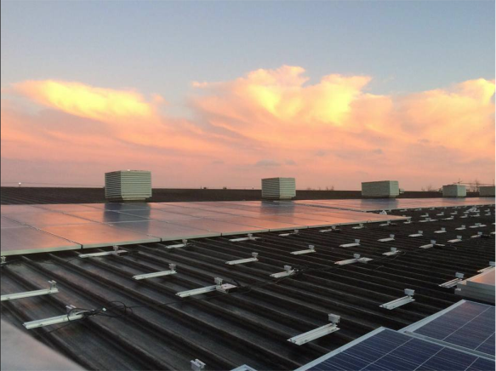
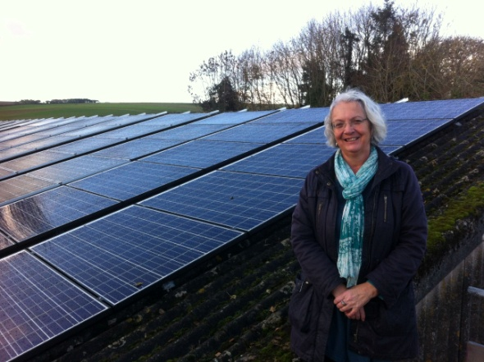
Shillingford Organics Solar Array Great Moor House Solar Array

Wonford Community and Learning Centre (WCLC)
The 20 kWp installation started generating on November 23rd after a 20 year lease was signed with Exeter City Council and a 20 year PPA with the trustees of WCLC. The installer was Hyde Park Electrical Ltd. Reducing energy costs for the centre means more money can be directed to improving core services.
Devon County Council (DCC)
There was a very tight timescale for the two DCC roofs – Exeter Central library and Great Moor House. We needed to complete the installation and commission both projects before the expected large January FiT reduction took place. Both were completed by Christmas due to the dedicated work by our two installers – SunGift Solar for Great Moor House and Sol Electrical for Exeter Central Library.
Great Moor House
Great Moor House is a large modern council office in Sowton with meeting, training and conference facilities. It is also the home of the Devon Heritage Centre, the Met Office Archive and houses all the ICT for DCC Schools. Generation started on December 17th and its many computers mean that it is extremely likely that all of the solar energy generated will be used onsite. An Energy Supply Agreement with DCC is the legal arrangement used for this site. Under this form of agreement, the ownership of the 100 kWp installation has passed to DCC, whilst ECOE has retained all the rights and benefits attached to the system.
Exeter Central Library
As well as the new 20 kWp installation, DCC has generously transferred the ownership of the existing 9 kWp to ECOE. This means we now own a 29kWp installation. A 20-year lease and PPA has been signed with DCC and our installation went live on December 23rd. In 2016 DCC will be signing a lease with a community mutual to manage the library, which will require ECOE to surrender the current PPA and re-assign it to the new tenant.

The remaining roofs from the Solar PV 1 portfolio
The directors had hoped for the remaining roofs to be fully installed by the end of March, but this turned out not to be possible. An update can be found later in this report.

Communications (Publicity, events and community engagement)
It’s been a busy year for ECOE and communicating with our supporters, stakeholders and the wider community of Exeter is central to the success of our organisations and our projects. We’ve arranged a series of educative events, which have included UK Energy Policy and the Role of Community energy with Catherine Mitchell and the Future of Community Energy. The latter was as a result of all of the changes to government policy last year. These changes unfortunately led us to cancel our Community Energy and Schools event. We had stalls at the Renewable Energy Marketplace, Respect Festival, the Green Fair, several in Princesshay and Embercombe’s autumn Open Day.

ECOE was a partner of Relight My Fire, an energy and arts festival organising ‘Pull the Plug’ pedal powered performances of local bands, ‘The Living Energy’ photo exhibition at Wonford Community and Learning Centre and ‘The Generation Game’, an interactive theatre game in which participants build a new self-sufficient Exeter.
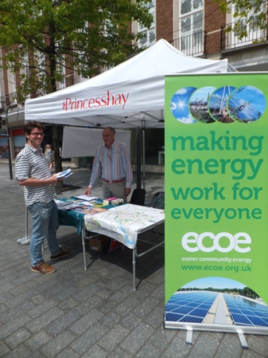
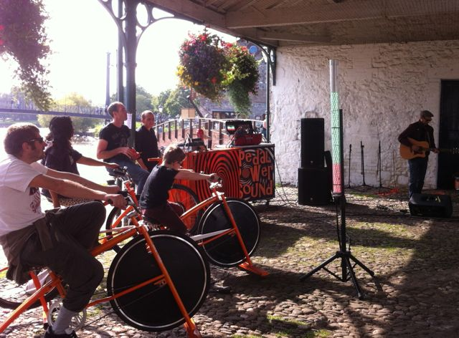

Stall in Princesshay Pull the Plug Pedal Power

We also gave talks at Exeter University, Exeter College, St David’s Neighbour Partnership AGM, Wonford Community and Learning Centre AGM, Pinhoe Road Baptist Church, the Alternatiba Festival and took part in a Green Party event with MEP Molly Scott-Cato.

Our supporters and volunteers are the lifeblood of ECOE. During this year our supporters have increased to about 600. Our volunteers database remain at about 40, some move away from Exeter and new people arrive. We held a volunteer evening in March, which was well attended and led to the setting up of our monthly social. The Finding Roofs working group was central to the success of Solar PV 1 and volunteers have also helped with running stalls, events, putting up posters, design, admin, photography and book-keeping. ECOE thanks all of our supporters and volunteers for all their work and support during the year.

In September ECOE said goodbye to Joe Smee, who had been responsible for Communications, when he left to go to Glasgow. He is sorely missed.

The climax of the year was our share offer in November. Daniel Hurring provided the competent marketing and publicity support for the share offer. We had numerous stalls to promote the share offer including at the Met Office and Devon County Council. We were not able to do as much site-based engagement as we would have liked due to the timescales.

Members
ECOE has been delighted to welcome over 200 new members who invested in Solar PV 1 and it has been particularly pleasing to see so many locally based investors.
All members should now be in receipt of an individual Share Certificate that was issued electronically. Volunteers have been supporting ECOE in ensuring that contact details are up to date and correct and, in the coming months, we will be setting up a secure data-base where members can log in and access their details directly.
ECOE has registered with the Information Commissioner's Office as a data controller, as we are required to do so under the Data Protection Act. We are committed to safeguarding members’ information and we will prioritise security.
The new Members page that has specifically been created for members, will communicate any member-related updates. This can be found at http://www.ecoe.org.uk/members/, which also includes a regularly updated FAQ’s detailing common queries around issues such as claiming tax relief through EIS.

Enterprise Investment Scheme (EIS)
ECOE has received advanced assurance that our project would qualify for the Enterprise Investment Scheme (EIS), which means that members will be able to claim 30% income tax relief on the money invested (provided that your tax liability for the same, or previous, year exceeds this sum). ECOE will contact HMRC and apply for EIS tax certificates for each member who wishes to claim this relief as soon as we have entered into commitments (signed legal agreements) to spend all of the share capital raised. Once the certificates are received they will be sent to those members requesting one. These certificates can then be applied in your self-assessment tax return for the tax year in which the investment was made i.e. 2015/16. We have been contacting members to ask if they intend to apply for the EIS tax refund so we only ask for those certificates we need.
Members with queries are encouraged to first view our Members page and if the answer is not there, to contact ECOE’s Member’s representative via members@ecoe.org.uk

Ground Mount Solar
During this financial year we investigated the possibility of ground mounted solar. We met with the farmer at Great Houndbeare, which went no further than this, and with Solstice Renewables at their site near Exeter Airport. We surveyed our supporters to ascertain support for ground mounted projects before agreeing in principle to take forward the project with Solstice. We spoke at their Planning appeal. However this appeal was turned down.

Summary of the Financial position
The accounts for this financial year show an accumulative loss of £23,758. This is in line with what was forecast in the business plan, drawn up in November 2015 to support the share offer, This deficit is due to the development costs of Solar PV 1 and will begin to fall after all the installations are complete. However, the delay in the installation of the remaining sites will impact upon the timing of when the accumulated deficit will be eliminated. More details about the accounts will follow later in the report on the Annual Accounts.

In January, Peter Bowers offered his services as a finance director. His secondment onto the board followed in February. Since then aspects of risk management have been assessed which has resulted in new finance procedures including paying invoices and setting up a new bank account with Nationwide Building Society so funds can be split between the new account and the existing Co-operative bank account. This helps spread the risk in the unlikely event that either should fail, as well as slightly improving the rate of interest we obtain on the funds held.

Now ECOE has a finance director, monthly management accounts are being prepared including a cashflow forecast, which will help us to plan when additional funds will be required.

Update since Jan 31st 2016 and the Future
The remaining Solar PV 1 Sites
Progress has been extremely slow. At the time of the share offer only heads of terms had been signed. As the negotiations at these five sites have continued, two sites have chosen not to progress – Newcourt Community Centre and Ashwoods Automotives. However Exeter College, a site not included in the share offer, informed ECOE they wanted the 150kWp installation to progress at the Technology Centre. This was very good news in the light of having lost some sites. It is currently expected that 50% of this site will be in Solar PV 1 to replace the two sites that have withdrawn and the other 50% will be in Solar PV 2.

Glasshouse Lane Medical Centre
The partners have agreed to the installation and we are waiting for their comments on the draft lease and PPA.

Pinhoe Road Baptist Church
We hope we will soon receive the go-ahead. Draft leases and PPA has been with the trustees for some time. It has been quite complex because of the additional clauses and conditions required because of the Landlord being a charity. For example, having an independent survey before signing the lease and deciding whether to replace the roof before or after the installation.

Honiton Community Complex (The Beehive)
ECOE is waiting to receive the go-ahead from Honiton Town Council (HTC). This is a slightly complicated transaction in that Honiton Community Complex (HCC) have a 10 year lease from HTC so, on completion, two leases and PPAs will need to be completed – one in respect of the first 10 years of the term with HCC and one for the second period of 10 years with HTC.

Exeter College, the Technology Centre
Negotiations to progress this site have been intricate, the college only agreeing to the scheme if there is a break clause in the lease. ECOE has agreed to this from the end of year 10 with a decreasing compensation, the later in the 20-year term this occurs.

We had hoped the 150kWp installation, by SunGift Solar who won the competitive tender, would start on April 24th, however a few remaining queries has delayed the start. Currently we hope the installation will start during the w/c 13th June.

Solar PV 2
ECOE pre-registered a further two sites in Exeter, and approx 15 sites for local groups in Crediton, Okehampton, Braunton and Swimbridge. Since then three local groups, ECOE, Energy Analysis and DARE have been investigating the possibility of progressing them.

The portfolio for Solar PV 2 is currently 125kWp. ECOE has been fortunate in arranging another interest free bridging loan from a private loan facility, which will enable us to install these sites, prior to launching our second community share offer. The sites are:
- Exeter College, Technology Centre (50%) – see before.
- Jubilee Hall, Swimbridge – they are keen to progress, they have received the draft PPA and lease, which will include charity clauses, independent survey and consent from the Big Lottery. All are underway.
- Lobb Football Pavilion – we recently received their agreement, so draft lease and PPA will be provided shortly.
- Southmead Primary School – their governors are very keen to proceed and a draft lease and PPA will be sent as soon as there is acknowledgement from DCC that they will support the installation.

Both of the Exeter sites are unlikely to progress – West Town Farm are in the middle of buying the farm from the Church and its looking like this process will not be completed in time for the installation to be completed by the end of September. Matthews Hall in Topsham has withdrawn because ECC would require them to take responsibility for the maintenance of the roof if they went ahead with the installation.
Community of Okehampton Renewable Energy Society (CORES) will be progressing the sites in Okehampton, starting with a pilot, Okehampton Glass. They will be leading the project including raising the finances, whilst ECOE will be supporting them. Once Ofgem has finalised the FiT payments, after the installation has been commissioned, ECOE will transfer ownership to CORE.

Sadly the governors at Queen Elizabeth College decided against the solar installation on several of their roofs – a huge disappointment for Sustainable Crediton Energy Group after all of their hard work; and for ECOE.

ECOE community fund
An important part of Solar PV 1 and Solar PV 2 is the revenue generated to go into a dedicated community energy fund, which ECOE will manage alongside its other activities. This fund will be used to support projects which promote energy efficiency and help to alleviate fuel poverty in Exeter. Community groups will be able to apply to the fund; and members, the local community and directors will assess applications and use a participative process to decide on which projects to support. This process is in development; we are open to input regarding how it should operate prior to making a first payment, hopefully following the AGM next year.

New ECOE heat project
ECOE have successfully won a second UCEF grant of £19,660 to bring another of our ambitions into reality – reducing carbon emissions from renewable heat. The funding will enable us to investigate different heat technologies for community buildings and social housing as well as researching legal agreements, finance and business models. The range of technologies being considered is:
- Biomass: burning of virgin wood, potentially from local sources, and waste materials in high efficiency boilers.
- Heat pumps: gathering low-grade heat from the ground, air or water and then using this to create heat more efficiently than using electricity on it's own.
- Combined Heat and Power: harnessing both the heat and power from a generator enabling greater efficiencies and, although normally gas-driven, this could come from anaerobic digestion.
- Anaerobic Digestion: generating biomethane from waste organic materials for use through the gas network or onsite in a Combined Heat and Power unit.
- Solar Thermal: generating of hot water using the sun's energy.
This is a new area for community energy groups with only a few share offers across the country and is an exciting opportunity for ECOE.

Energy Efficiency Working Group
After some positive discussions around Energy Efficiency at ECOE events, we have launched an Energy Efficiency Working Group. It builds on the Big Community Energy Weekend in 2014, which included a Green Open Homes weekend and an Energy Fair. It will assess what is already happening in Exeter and research the experience of other community energy groups before deciding on its specific aims and the types of projects to achieve them.
The current possible projects areas are:
- “Shifting the Peak”: A project looking at shifting demand and saving on the cost of bills through using energy at different times.
- Street by street energy efficiency project: An intensive street by street project targeting fuel poverty, initially highlighted by Transition Exeter’s Leaf Report.
- Shop Front: A visible shop front presence to Energy Efficiency and ECOE’s ongoing projects.

Energy Supply and Storage
Local energy supply and energy storage could fundamentally change our energy system. Communities across the UK are no longer satisfied with a centralised, carbon intensive energy market that is dominated by the big six.
Instead, many have expressed a desire to have a stake in local, low carbon energy generation and management projects. The natural progression from community owned generation is to use and sell that energy within the local community. When the economic benefits of local generation can be shared with the whole community, the development of new generation can become much more acceptable. A closer relationship with the energy we use can also help us manage it more effectively. There are a large number of options available for local supply and it is a possible future project for ECOE that would keep the benefits of renewable generation locally.

Another possibility that would maximize the efficient use of community-owned generation is energy storage. Technological breakthroughs have resulted in a drastic reduction in cost and size and an increase in safety, longevity and usability. Some trials are currently being undertaken with battery storage on solar farms. Combining the ability to export solar electricity at different times through the use of battery storage with local supply and the local economy, will benefit the environment and community significantly.
Funding Opportunities
ECOE directors are considering different funding possibilities. One is the Power to Change programme and its Community Business Fund, which supports community businesses to become more financially sustainable. Grants from between £50,000 - £300,000 are available. It’s a very competitive process but could finance a major new project for ECOE ensuring our viability for years to come. We have approached Granted Consultancy for support in preparing our application.

Other possibilities include The Peoples Lottery, The Tudor Trust partnering with Regen SW and NEA Smart Meter funding.

Events detailed in this report that occurred after the end of our financial year are clearly distinguished

