Community Energy and Social Value

One of the strengths of community energy projects are their social outcomes – such as community cohesion, reducing fuel poverty, education and re-investment of profits, as well as an interest in sustainability. All groups depend on volunteers and rely heavily on gaining broad support within a local community for their activities. Many groups are set up as co-operatives, registered societies for the benefit of the community and community interest companies.

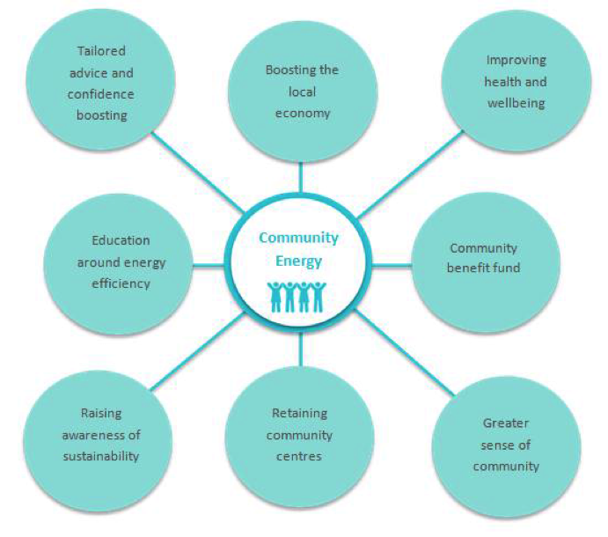

Key Benefits
Promoting sustainability
Community energy projects provide a local and practical example of low carbon projects that local people support, learn and invest in. Being involved in community energy changes the community from being passive consumers to active producers. Renewable energy and energy saving projects save carbon and raise awareness of a low-carbon lifestyle to help with mitigating climate chaos.

Resilience and reinvestment:
The income supports a community benefit fund that can be used to finance local projects that increase the energy efficiency of local houses and community buildings, protecting against the impact of fluctuating fuel prices. Over the course of the solar PV project ECOE plans to make £220,000 available for their community benefit fund. This will help with small projects – providing double-glazing to a cold damp office at Wonford Community and Learning Centre; and large Projects – ECOE has developed a Healthy Homes for Well Being Project that promotes, energy advice, the installation of low cost energy saving measures, switching, registration on priority registers, income maximization and grant information about high cost energy saving measures to vulnerable households linking cold damp homes, fuel poverty and poor physical and mental health. This will be partially funded from the ECOE Community Fund.

Community empowerment:
Engagement in a significant long term project such as development of new renewable energy generation involves local people in a range of activities, improving skills and confidence. By making collective decisions about the use and distribution of income local communities also develop greater self determination through the direct control of local resources.

Education:
Community energy groups run educations events on all aspects of energy and have stalls at a range of community events. ECOE has provided information about renewable energy projects as a low carbon local practical action at Respect, The Green Fair, TedEx, events at the University. Events have included a visit to the Energy Recovery Centre, Community Energy Innovations in Energy Efficiency, Opportunities for Renewable Heat and Heat Networks, Energy and Brexit, accompanying Cubs to a visit of the Solar PV at the Met Office.

Renewable generation installations attract school and college visits and student projects. They provide direct experience of the application of science and technology; study sites for a range of disciplines, and opportunities for technical skills development, connecting people to where their energy comes from. In 2012 as well as visits from local schools Torrs Hydro in Derbyshire attracted students from Cardiff, Aberdeen, Sheffield, Bath and Manchester universities.

Sense of ownership and social cohesion:
A community energy group can ensure the local community feels a part of the renewable energy project. They are known by the local community and will engage the local community so their views are taken into account and invite them to take an active part in the project from the beginning. Thus the type and size of the installation ensures appropriate scale technology is installed which is sensitive to the landscape and the needs of the local community. The collective endeavour of developing and managing such sites can improve social cohesion, creating new networks and connections between individuals.

Local economy:
While much of the hardware and technology is sourced from outside the UK, the planning, survey and engineering works all provide local employment opportunities, and the income from schemes strengthens the local economy. ECOE has used local contractors for all of their rooftop solar installations.

Existing schemes also reported that the renewables installations themselves can become visitor attractions, attracting new visitors and retaining them longer. Torrs Hydro estimate that 1000 people per year visit the site, which is included in the annual lantern parade and is used as a site for art installations during the local art festival. The turbine, which has been named “Archie” by local school children, is ranked as the second most popular visitor attraction in New Mills on the Trip Advisor website.

